**RAJALAKSHMI ENGINEERING COLLEGE**

**RAJALAKSHMI NAGAR, THANDALAM – 602 105**



|  |
| --- |
| **CS23A34**  **USER INTERFACE AND DESIGN LAB** |
| **Laboratory Observation NoteBook** |

|  |
| --- |
| **Name :** SREYASKARI M  **Year/Branch/Section :** II/CSE/D  **Register No. :** 230701335  **Semester :** IV  **Academic Year:** 2024-25 |

**Ex. No. : 4a**

**Register No. : 230701335 Name : Sreyaskari M**

**Conduct task analysis for an app (e.g., online shopping) and document user flows. Create corresponding wireframes using Lucidchart**

**Aim:**

To understand and document the steps a user takes to complete the main tasks within an online shopping app.

**Procedure:**

#### Step 1: Assigning Tasks

1. Browsing Products
2. Searching for a Specific Product
3. Adding a Product to the Cart
4. Checking Out

### Step 2: Document User Flows

#### 1. Browsing Products

1. Home Screen: User lands on the home page with product categories.
2. Product Categories: User taps on a category to view products.
3. Product List: User scrolls through the product list.
4. Product Details: User taps on a specific product to see details.

Home Screen -> Product Categories -> Product List -> Product Details

#### 2. Searching for a Specific Product

1. Search: User taps the search bar or icon.
2. Enter Query: User types the product name or keyword.
3. Search Results: User reviews matching items.
4. Product Details: User taps on a specific product to see details.

Search -> Enter Query -> Search Results -> Product Details

#### 3. Adding a Product to the Cart

1. View Products: User browses or searches for a product.
2. Product Details: User taps on the product to see more info.
3. Add to Cart: User clicks "Add to Cart".

View Products -> Product Details -> Add to Cart

#### 4. Checking Out

1. Open Cart: User taps on the cart icon.
2. Review Cart: User checks all products.
3. Proceed to Checkout: User clicks "Checkout".
4. Enter Shipping Info: User provides shipping details.
5. Enter Payment Info: User provides payment details.
6. Place Order: User clicks "Place Order".

Open Cart -> Review Cart -> Proceed to Checkout -> Enter Shipping Info -> Enter Payment Info -> Place Order

### Step-by-Step Procedure to Create User Flows in Lucidchart

#### 1. Create a New Document

* Go to Lucidchart and sign in or sign up if you don't have an account.
* Click on + Document or Create New Diagram.

#### 2. Select a Template

* You can start with a blank document or select a flowchart template.
* For this example, let's start with a blank document.

#### 3. Add Shapes for Each Step

* Drag and drop shapes from the left sidebar to represent different steps in your flow (e.g., rectangles for actions, diamonds for decisions).
* Name each shape based on the steps from the task analysis:
  + Login/Register
  + Browsing Products
  + Adding Products to Cart
  + Managing Cart
  + Checkout Process
  + Tracking Orders

#### 4. Connect the Shapes

* Use connectors to link the shapes, indicating the flow from one step to the next.
* Add arrows to show the direction of the flow.

#### 5. Add Details to Each Step

* Double-click on each shape to add text describing the action or decision.
* For example, for the "Login/Register" step, you might add:
  + Open the app
  + Click on "Sign Up" or "Login"
  + Enter details (username, email, password)
  + Click "Submit"
  + Verification through email or phone (if required)
  + Redirect to the home screen upon successful login

#### 6. Use Different Shapes for Different Actions

* Use rectangles for general actions.
* Use diamonds for decision points (e.g., "Is the user logged in?").
* Use ovals for start and end points.

#### 7. Customize and Organize Your Flowchart

* Arrange the shapes and connectors logically.
* Use different colors to distinguish between types of steps or user roles.
* Group related steps into sections for better clarity.

#### 8. Review and Save Your Flowchart

* Review the flowchart to ensure all steps are included and connected correctly.
* Save your flowchart by clicking on File -> Save.

#### 9. Share and Collaborate

* Click on the Share button to collaborate with others.
* You can also export your flowchart as an image or PDF for presentation purposes.

### Example Flowchart Breakdown:

#### Login/Register Flow

* Steps:
  + Open the app
  + Click on "Login" or "Register"
  + Enter details
  + Verify (if required)
  + Redirect to the home screen

#### Browse and Search Flow

* Steps:
  + Navigate to categories or use search bar
  + Apply filters/sorting options
  + View product details

#### Add to Cart Flow

* Steps:
  + View product details
  + Select options (size, color, quantity)
  + Add product to cart

#### Checkout Flow

* Steps:
  + Review cart
  + Proceed to checkout
  + Enter shipping information
  + Select payment method
  + Confirm and place order

#### Order Tracking Flow

* Steps:
  + Navigate to "My Orders"
  + Select order to track
  + View tracking details

**Output:**

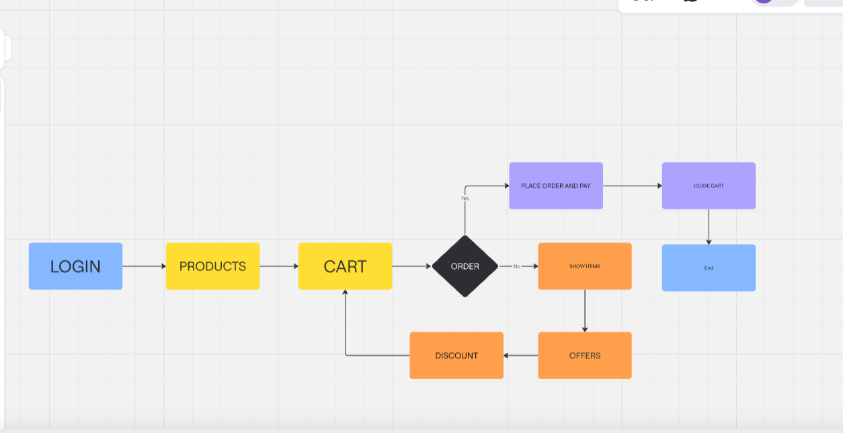

**Result:**

Hence conducted the task analysis for an app (e.g., online shopping) and documented the user flows. Created corresponding wireframes using Lucidchart has been successfully done.